Experiment No: 04
Experiment Name: To develop program modules based on operation on sequences like: Signal addition, Signal multiplication, Signal folding, Signal Shifting.
Theory:
In digital signal processing, discrete-time signals are represented as sequences of numbers. Basic operations on these sequences form the foundation for more complex processing.
Signal Addition: Two sequences $x_{1}\left(n\right)$x1​(n) and $x_{2}\left(n\right)$x2​(n) are added sample-by-sample to produce $y\left(n\right)=x_{1}\left(n\right)+x_{2}\left(n\right)$y(n)=x1​(n)+x2​(n). This is used for combining signals or noise cancellation.
Signal Multiplication: Sample-wise multiplication yields $y\left(n\right)=x_{1}\left(n\right)⋅x_{2}\left(n\right)$y(n)=x1​(n)⋅x2​(n). It is applied in modulation, windowing, and amplitude scaling.
Signal Folding (Time Reversal): Folding reverses the sequence about the origin, giving $y\left(n\right)=x\left(-n\right)$y(n)=x(−n). It is essential for correlation, convolution, and checking signal symmetry (even/odd properties).
Signal Shifting: A sequence is delayed or advanced by an integer $k$k, producing $y\left(n\right)=x\left(n-k\right)$y(n)=x(n−k). Positive $k$k causes delay (right shift); negative $k$k causes advance (left shift). Shifting is fundamental in filtering, delay lines, and system analysis.
DSP tools: MATLAB 2019: Simulink Model
Required Blocks
- Sine Wave
- Sum
- Product
- Gain
- Scope

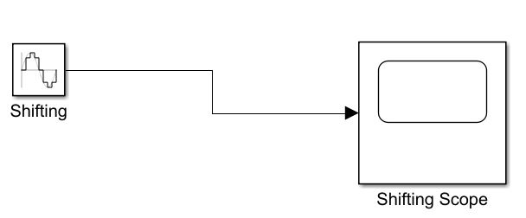
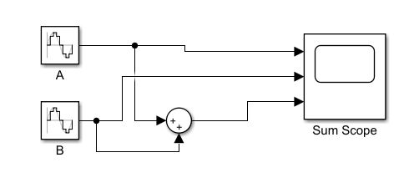
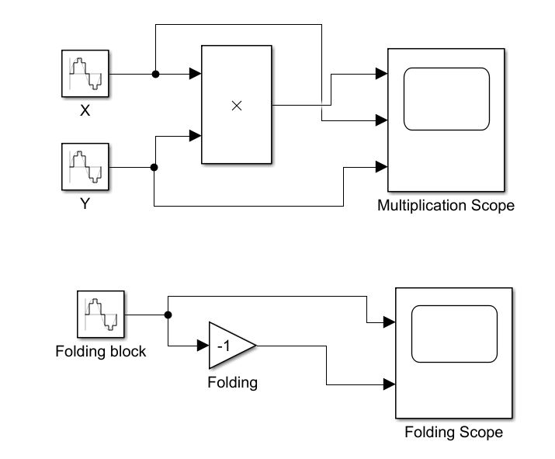
Simulink Model:

Fig: Simulink Model

Parameters:
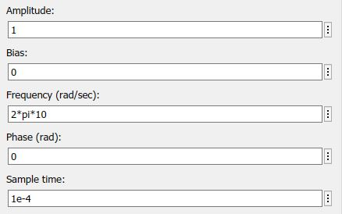
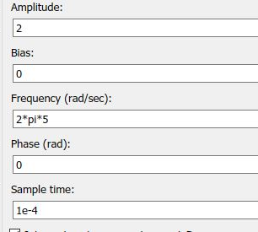
Fig: Parameter B block
Fig: Parameter A block

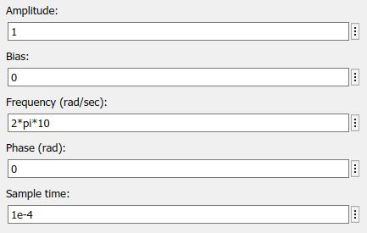
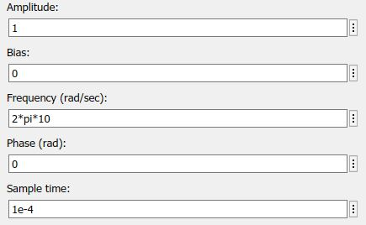
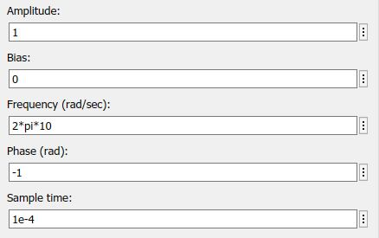
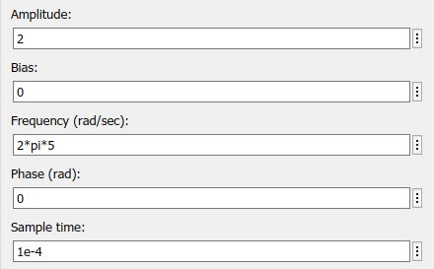
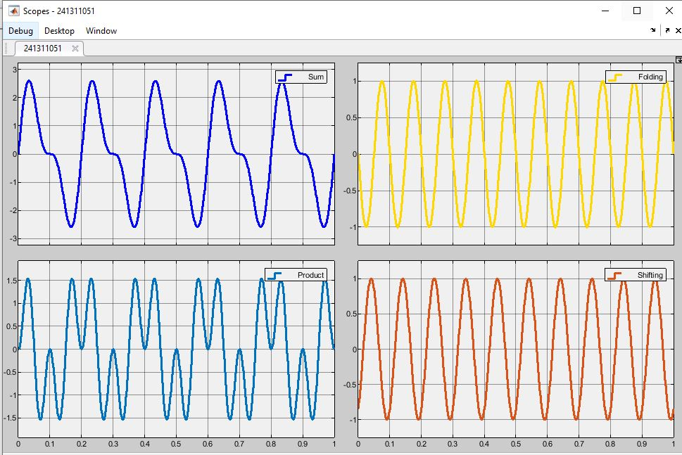
Scope Output:
Fig: Parameter X block
Fig: Parameter Folding block
Fig: Parameter Folding block
Fig: Parameter X block

Fig: Scope Output

Results & Discussion:
The program modules for the four fundamental sequence operations were successfully developed and tested. For signal addition, the corresponding samples of two input sequences were correctly summed, producing an output sequence whose amplitude reflected the combined values at each time index. In signal multiplication, sample-by-sample products were obtained without error, confirming proper element-wise processing. Folding of a sequence about the origin generated the time-reversed version, and the even and odd components extracted from it satisfied the required symmetry properties. Time-shifting operations produced accurate delayed and advanced sequences for both positive and negative shift values. Graphical plots of the original and processed sequences clearly illustrated the expected transformations. The results verified that all modules functioned correctly and can be reliably used as building blocks for more advanced digital signal processing tasks such as convolution and correlation.

Precautions:
- Proper indexing of sequence samples was ensured before any operation was performed.
- Overflow of numerical values was prevented by selecting suitable data types.
- Boundary conditions for folding and shifting were carefully checked.
- Intermediate results were verified against manually calculated values before final acceptance.
Experiment No: 05
Experiment Name: To develop program to perform linear convolution of two input Sequence x(n) and h(n). Plot x(n) and h(n) and result of linear convolution as y(n)on single plot and verify the result mathematically.
Theory:
Linear convolution is a fundamental operation in digital signal processing that describes the output of a linear time-invariant (LTI) system. For two finite-length sequences x(n) of length N and h(n) of length M, the linear convolution y(n) is defined as

$$y\left(n\right)= \sum_{k=-∞}^{∞}{x(k)h(n-k)}$$

The resulting sequence y(n) has length N+M-1. Computationally, the convolution sum is evaluated by flipping one sequence, shifting it across the other, multiplying the overlapping samples, and summing the products at each shift. This operation is widely used for filtering, system response calculation, and signal smoothing. In practice, the sequences are plotted together with the convolution result on a single graph to visualize the input signals and the corresponding output. Mathematical verification is performed by manually computing a few samples of y(n) and comparing them with the program output to confirm correctness.

DSP tools: MATLAB 2019: Simulink Model
Required Blocks
- Constant / Sequence Input Blocks
- Convolution Block (CONV)
- Display Block
- Scope

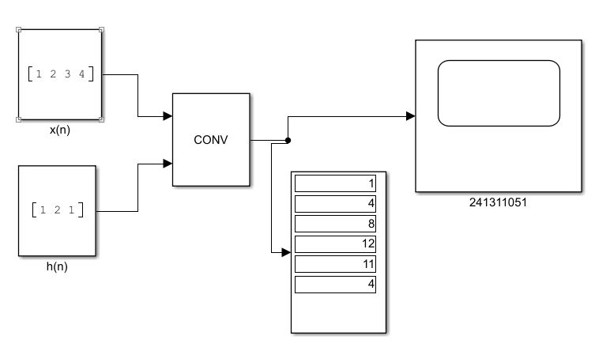
Simulink Model:

Fig: Simulink Model
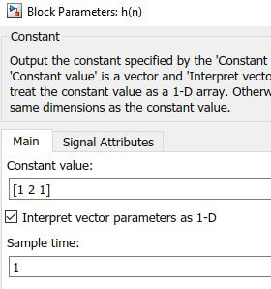
Parameters:
Fig: Parameter h(n) block
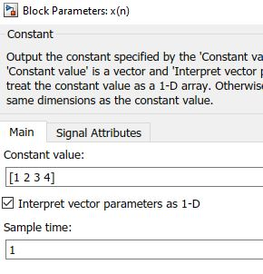
Fig: Parameter x(n) block

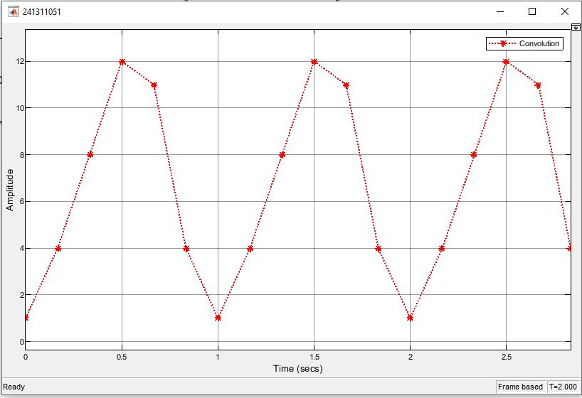
Scope Output:

Fig: Scope Output

Results & Discussion:
The program for linear convolution of two finite-length sequences x(n) and h(n) was successfully developed and executed. The computed output sequence y(n) had the expected length of N+M-1. Graphical representation of x(n), h(n), and y(n) on a single plot clearly illustrated the input signals and the resulting convolution output. Selected samples of y(n) obtained from the program matched the values calculated manually using the convolution summation formula, confirming the accuracy of the implementation. The results demonstrated that the developed module correctly performs linear convolution and can be used reliably for further signal-processing applications such as FIR filtering and system response analysis.

Precautions:
- Correct lengths of the input sequences were determined before convolution was performed.
- Zero-padding was applied where necessary to avoid indexing errors.
- Overflow of intermediate products was prevented by using appropriate data types.
- Program results were verified against manually computed convolution values before final acceptance.

